**Appendix**

|  |  |
| --- | --- |
| **Female Recipes** | |
| Almond Fig Banana Smoothie | Broccoli Lentil Apple Salad |
| Nectarine and Blueberry Overnight Oats | Beef and Broccoli Stir-Fry |
| Fish and Sweet Potato Chips | Grilled Thai Beef Salad |
| Breakfast Bruschetta | Spiralised Zucchini Hash |
| Thai Fish Cakes | Pumpkin and Cheese Quesadilla |
| Greek Pies | Banana and Almond Overnight Oats |
| Tandoori Fish with Avocado Salad | Roasted Vegetable Chicken Salad |
| Pocket Pitas with Grilled Fish | Almond Hit Smoothie |

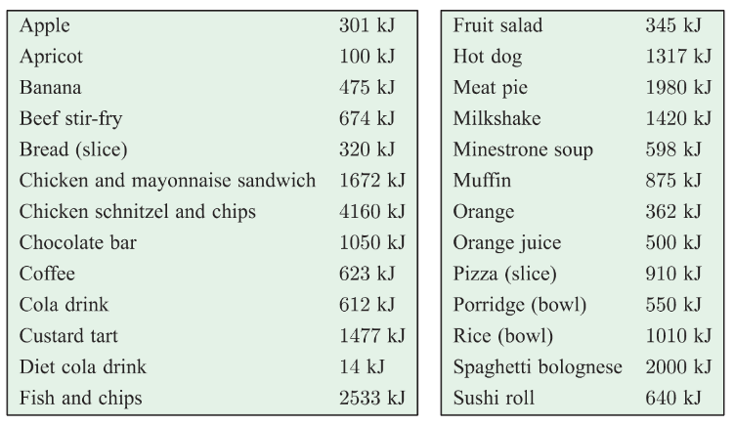

|  |  |
| --- | --- |
| **Male Recipes** | |
| Almond Fig Banana Smoothie | Broccoli Lentil Apple Salad |
| Nectarine and Blueberry Overnight Oats | Beef and Broccoli Stir-Fry |
| Fish and Sweet Potato Chips | Grilled Thai Beef Salad |
| Breakfast Bruschetta | Spiralised Zucchini Hash |
| Thai Fish Cakes | Cherry Ripe Smoothie |
| BBQ Lemon Chicken with Potato Salad | Smashed Chickpea and Avo Wrap |
| Lamb Souvlaki | Quick Banana Pancakes |
| Salmon Patties with a Bean Salad | Chicken Schnitzel with Apple Slaw |